**PROJECT NAME: VIRNDA STORE – DATA ANALYSIS USING EXCEL**

**BUSINESS PROBLEM STATEMENT:**

Vrinda wants to create an annual sales report for 2022. So that, Vrinda understand their customers and grow more sales in 2023

**What Insights they major want to look into :**

* Compare the sales and orders using single chart
* Which month got the highest sales and orders ?
* Who purchased more - men or women in 2022?
* What are the different order status in 2022?
* List top 5 states contributing to the sales?
* Relation between age and gender based on number of orders
* which channel is contributing to maximum sales?
* Highest Selling category? etc...

**Data set Link :**

<https://docs.google.com/spreadsheets/d/1N_Aa45UnkPmnwGqNr6oTzvUhb5TKlitM/edit?rtpof=true&sd=true>

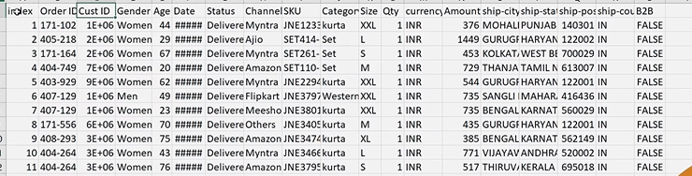

**Understand The Data:**

It’s a sales data of vrinda store of financial year 2022 which contains

Index, Order Id, Customer id , Gender, Age , Date, Status, SKU, Category , Size , Qty, currency, Amount, Ship-city, Ship-State, Ship-pincode, Ship-country, B2B columns

**Data Cleaning:**

Data cleaning is the process of fixing or removing incorrect, corrupted, incorrectly formatted, duplicate, or incomplete data within a dataset.

Cross check for each column related data If it is numeric data it should have values, No duplicates, are the data is in correct Format, No Null values, Data Consistence (Men, Women only), No outliers, Applied filters, replace the data with the correct format…

**Data Processing :**

Data cleaning is the process of fixing or removing incorrect, corrupted, incorrectly formatted, duplicate, or incomplete data within a dataset.

Did some calculations, categorize the Age data into different group based on the range Separated: (Teenagers, Adults, Seniors), Inserted the month column and Extracted the month from date

**Data Analysis :**

Data analysis is a process for obtaining raw data, and subsequently converting it into information useful for decision-making by users. Data is collected and analyzed to answer questions, test hypotheses, or disprove theories

Created the pivot tables, Pivot Charts based on the requirements, which helped in analyzing the data

No of orders per Months and Sales per Month:

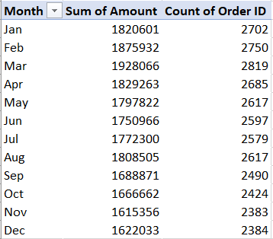

Men Vs Women Sales Report:

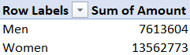

Order Status:

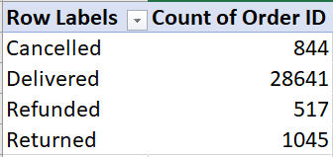

State wise Sales:

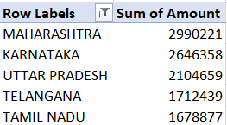

Age Vs Gender:

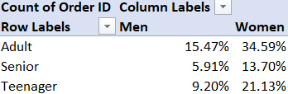

Order Channel:

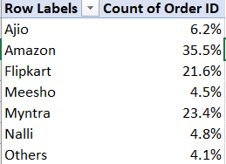

**Data Visualization:**

Data visualization is the representation of data through use of common graphics, such as charts, plots, infographics, and even animations. These visual displays of information communicate complex data relationships and data-driven insights in a way that is easy to understand.

Created the Pivot Charts from pivot tables each for the above Data analysis

Create a dashboard – VRINDA ANNUAL SALES REPORT -2022

Grouped the pivot charts in one place and added the slicers to link the Pivot charts, which helped in analysis the data and Visualizing at a time in one place.

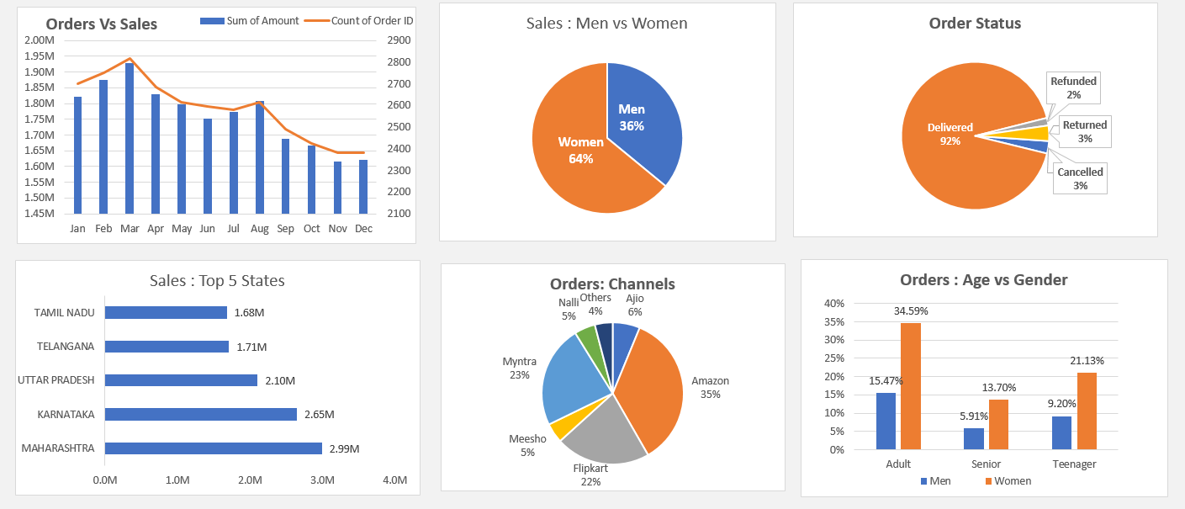

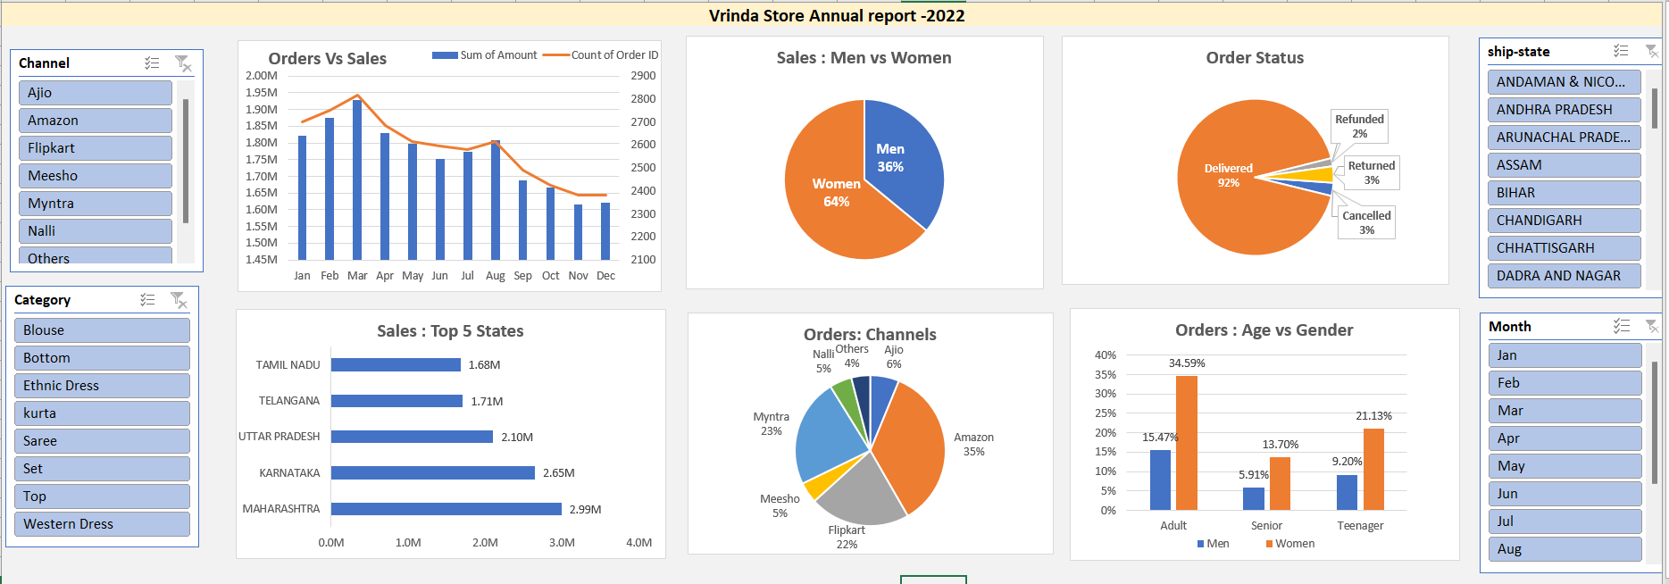

**Insights from 2022 Report**

* Maximum Orders in made in March month
* Initial Jan, Feb, March are the month we can see increase in orders
* No. of orders are decreasing, there by the Revenue of the store is decreasing month on month
* Percentage of Women buying from the store is more than the percentage of men
* Percentage of no. of women in Adult category Shopping is more than compare to Senior and Teenage groups
* Most of the orders are placed from Amazon, then Flipkart and Myntra
* Top 5 states with maximum sales are Maharashtra, Tamil Nadu, Uttar Pradesh, Telangana, Karnataka. Most of the orders are coming from Maharashtra state

**Improve the Sales in 2023:**

* Focusing on the Women in Adult group
* Increase fast delivery service in top 5 states
* Research on the products sold maximum in Month of Jan, Feb, Mar. Add them or increase the units, If any changes made after march reverse it
* Take customer feedback and review to increase the sales